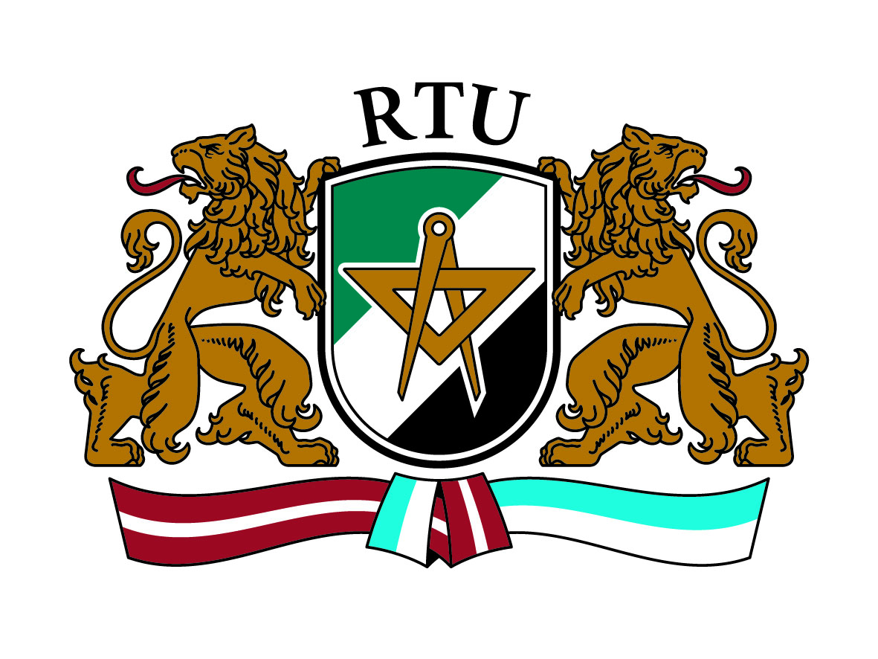 | Application Form  3rd INTERNATIONAL STAFF TRAINING WEEK  May 26 – 30, 2014  Riga Technical University

Title:
Surname:
Name:
City and country:
University:
Department:
Position:
Main responsibilities:

Contact data:
Address
E-mail
Telephone / mobile

Erasmus code:

Name and e-mail of Erasmus coordinator at your institution:

Please state the reasons for participation at the International Week 2014 organized by RTU:

According to the planned program, I will join:
- Individual meetings (please indicate 3 choices (1, 2, 3) in order of preference):
Please tick off | YES | NO
Faculty of Architecture and Urban Planning
Faculty of Civil Engineering
Faculty of Computer Science and Information Technology
Faculty of Electronics and Telecommunications
Faculty of Engineering Economics and Management
Faculty of Materials Science and Applied Chemistry
Faculty of Power and Electrical Engineering
Faculty of Transport and Mechanical Engineering
Riga Business School
Institute of Applied Linguistics
Scientific Library
International Relations Department
Foreign Students Department
Other (please specify):
- Welcome dinner
- Riga city tour
- Tour to Jūrmala (www.jurmala.lv)

Please send your completed application form before 22 April 2014 to e-mail jolanta.jurevica@rtu.lv

