INTERNSHIP PROCESS
- Student determines the firm to do internship,
- 3 ‘Compulsory – Voluntary İnternship Form’ printouts can be taken from www.isikun.edu.tr and filled in, a photo should be attached to each of the forms.
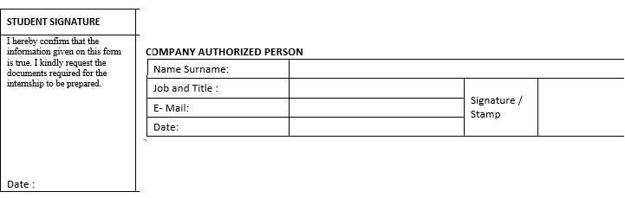
- Compulsory Internship Form which is signed and stamped by the internship company is firstly signed by the department where the student is located and then by the Faculty (Dean’s Office).

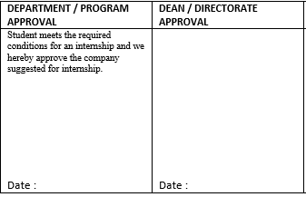
- İnternship start and end dates in the ‘ Compulsory Internship Form must be written correctly according to the period of internship ( 20 - 40 days)

If you are working on Saturdays and Sundays, you should be informed about the internship form and the signed and stamped letter should be taken from the employer on Saturday or Sunday.
If you are working on certain days of the week, you must specify the number of days and days in which you work in the days of internship.
It should be stated whether or not they are working on general holidays (National Day, Religious Day, and New Year).
Internship days not worked for the internship period must be subtracted from the start end date of the internship.
- www.isikun.edu.tr Internship Employer İnformation Form printout should be taken and filled, signed and stamped by the company.
*** If the student receives a fee from the company where he/she does internship, he / she should indicate the bank IBAN information, bank branch and the number of personnel he / she has employed in the form.
- The document which states that the students is under the coverage of parents’ SGK should be taken and submitted.
- Identity or passport photocopy is attached.
- All application forms and signed documents must be submitted to the İnternship Coordinator by the student at least 15 days before the start of the İnternship. Forms not submitted on time will not be processed.
- Students who are currently continuing their internship should get approval from their Faculty when they wish to extend their internship. If approved, the end date of the internship should be updated by asking the department teacher who should send an approval mail to the İnternship Coordinator.
- Internship documents that cannot be received by the students, can be delivered by any relative or friend. However, the name and surname of the receiving person must be registered by the internship coordinator.
- In case foreign students want to do an internship abroad, SGK transactions cannot be made in accordance with legal rules.

