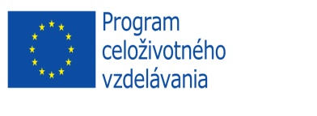

Erasmus Placements in Companies
Placement Description

COMPANY OVERVIEW
NAME OF THE COMPANY | BizPartner a.s.
ADDRESS | Dlhé Hony 6, 05801 Poprad
COUNTRY | Slovakia
WEB PAGE | www.bizpartnergroup.eu, www.feegloo.com
SHORT INFORMATION ABOUT COMPANY | www.feegloo.com
CONTACT PERSON | Martin Fodor
CONTACT DETAILS  (E-MAIL, TEL. NO.) | bizpartner @bizpartner.sk, 00421911660535
REQUESTED ERASMUS STUDENT PROFILE | Erasmus student
FIELD OF STUDIES/PROFESSIONAL AREAS OF INTEREST | Marketing, management, media, strategy marketing, project management
TASKS | Online communication, social media, articles marketing ideas
REQUIREMENTS (LANGUAGES AND OTHER COMPETENCES) | ENG
PAYMENT OR OTHER BENEFITS | Accommodation and meals
PLACEMENT DURATION | 3-6 months
PLACEMENT PERIOD  (FROM - TO) | ---------------------
OTHER INFORMATION | ---------------------

