INTERNSHIP APPLICATION PROCESS
A. If on-site internship will be done in companies abroad, the following process should be followed.
- Student determines the firm to do internship,
- The student downloads 1 'Compulsory Internship Form' from https://www.isikun.edu.tr/staj-koordinatorlugu/formlar and fills in his/her own information in the computer environment, pastes a photograph, fills in the information of the institution where the internship is done, 'Compulsory Internship Form Writes the start and end dates of the internship and the duration of the internship (20-40 days) in the .
It is important to fill the form in computer environment.
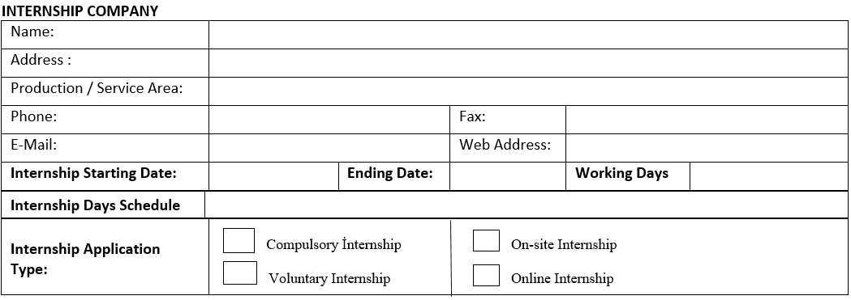
- After completing the ' Internship Form' on the computer, the student pastes 1 picture on the form and firstly, the student signs the form with wet signatures and then receives a wet signature – stamp from the company where the internship will be held, or the student sends the form to the company by e-mail. Then it scans it and sends it back to the student via e-mail.
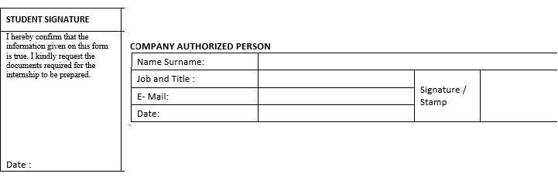
- The student sends the ' Internship Form' signed and stamped by the company where the internship will be held by e-mail to the advisor of the department in charge of the internship and receives approval.

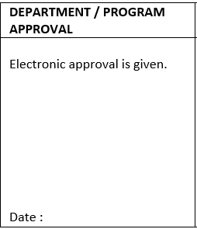

- The student scans her/his ID or Passport from the printer.
- The student scans the internship application form and student ID approved by the instructor responsible for the internship, together with the confirmation e-mail from the teacher, and the day before the start of the compulsory/voluntary internship in at least 15 relevant Faculty/Vocational School departments. sends an e-mail to his secretary.
- The Faculty/Vocational School Secretariat submits all the documents of the students to the Dean's Office/Directorate for approval through the Electronic Document Management System.

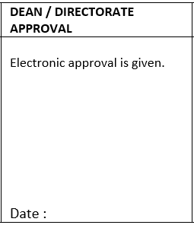
- The Internship Coordinator records the student's data in line with the approval received from the relevant Faculty/Vocational School Dean/Directorate via the Electronic Document Management System.
- In case foreign students want to do an internship abroad, SGK transactions cannot be made in accordance with legal rules.
- Faculty Approval Letter is sent to the students by e-mail by the department secretariat.
- When students who are currently in internship want to extend their internship, the student receives approval by e-mail from the instructor in charge of the internship. If approved, the student sends the confirmation e-mail from the department teacher to the Internship Coordinator. The internship end date is updated according to the approval given.
- When canceling the internship, the student writes a petition stating the reason and sends it to the related Faculty/Vocational School department secretariat by e-mail.

B. If internships will be made in companies in Türkiye and online from Türkiye in companies abroad, the following process should be followed.
- Student determines the firm to do internship,
- The student downloads 1 'Compulsory Internship Form' from https://www.isikun.edu.tr/staj-koordinatorlugu/formlar and fills in his/her own information in the computer environment, pastes a photograph, fills in the information of the institution where the internship is done, 'Compulsory Internship Form Writes the start and end dates of the internship and the duration of the internship (20-40 days) in the .
It is important to fill the form in computer environment.
*** If working on Saturdays and Sundays, information must be added to the Internship Form to the Internship Days section and at the same time, a signed and stamped letter must be obtained from the employer stating that they work on Saturdays or Sundays.
If working on certain days of the week, the number of days per week and which days of work should be specified in the days of internship in the compulsory internship form.
It should be stated whether there is work or not on general holidays (National Holiday, Religious Holiday, New Year's). If working, a signed and stamped letter should be obtained from the company.
If there is no work during the general holidays, it should be deducted from the internship day.
The internship end date should be calculated and written according to the internship period, not taking into account the days not worked for the start-end dates of the internship.
- The student downloads the ‘İşveren Bilgi Formu' from the address https://www.isikun.edu.tr/staj-koordinatorlugu/formlar , fills in his/her own information in the computer environment and fills out the information belonging to the company from the company where the internship will be done, and wet signature - stamp or the student sends the form to the company by e-mail, the company prints the form and sends it back to the student by e-mail, after scanning it with a wet signature and stamping.
*** If the student receives wages from the company where he/she does his internship, he/she should indicate the company's bank IBAN information, bank branch, and the number of personnel employed in the form. It is important that this information is filled in the computer environment.

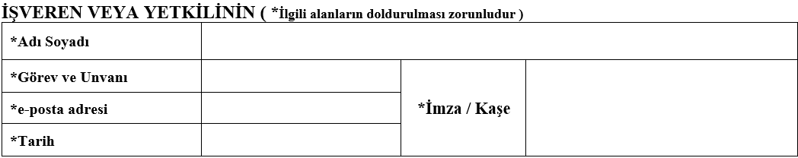

- After completing the ' Internship Form' on the computer, the student pastes 1 picture on the form and firstly, the student signs the form with wet signatures and then receives a wet signature – stamp from the company where the internship will be held, or the student sends the form to the company by e-mail. Then it scans it and sends it back to the student via e-mail.

- The student sends the ' Internship Form' signed and stamped by the company where the internship will be held by e-mail to the advisor of the department in charge of the internship and receives approval.

- The student downloads the ‘Beyan ve Taahhütname’, which indicates the status of benefiting from parents in terms of SGK in Türkiye, from the address https://www.isikun.edu.tr/staj-koordinatorlugu/formlar , fills out any of the student's own status in the computer environment and takes the printout. wet signatures.
If the student benefits from parents in terms of Social Security in Türkiye, the document no 22 should be filled.
If the student does not benefit from parents in terms of Social Security in Türkiye (if the parents do not have SGK, your SGK premium is optionally paid by you, if you work somewhere with SGK, if you are your own company and you are a member of BAĞKUR), the document numbered 43 should be filled.

- The student scans her/his ID or Passport from the printer.
- The student, by scanning the internship application form, employer information form, declaration and undertaking and student ID approved by the instructor in charge of the internship, together with the confirmation e-mail from the teacher, must submit all documents at least 15 days before the start date of the compulsory/voluntary internship in the relevant Faculty / Vocational School department. sends an e-mail to his secretary.
- The Faculty/Vocational School Secretariat submits all the documents of the students to the Dean's Office/Directorate for approval through the Electronic Document Management System.

- The Internship Coordinator carries out the student's data registration and SGK procedures in line with the approval received from the relevant Faculty/Vocational School Dean's Office/Directorate via the Electronic Document Management System.
- The Internship Coordinatorship sends the declarations of the students whose SGK procedures are done before the internship start date to the Faculty/Vocational School Dean's Office/Directorate regarding the Electronic Document Management System.
- SGK Statement + Faculty Approval Letter + Internship Coord. The Approval Letter is sent to the students by e-mail by the department secretariat.
- When students who are currently in internship want to extend their internship, the student receives approval by e-mail from the instructor in charge of the internship. If approved, the student sends the confirmation e-mail from the department teacher to the Internship Coordinator. The internship end date is updated according to the approval given.
- When canceling the internship, the student writes a petition stating the reason and sends it to the related Faculty/Vocational School department secretariat by e-mail.

